Create an sns topic

Create a lambda function for sns

Use this code

import json

def lambda_handler(event, context):

# TODO implement

print(event)

return 'ok'

create the subscription for the current topic

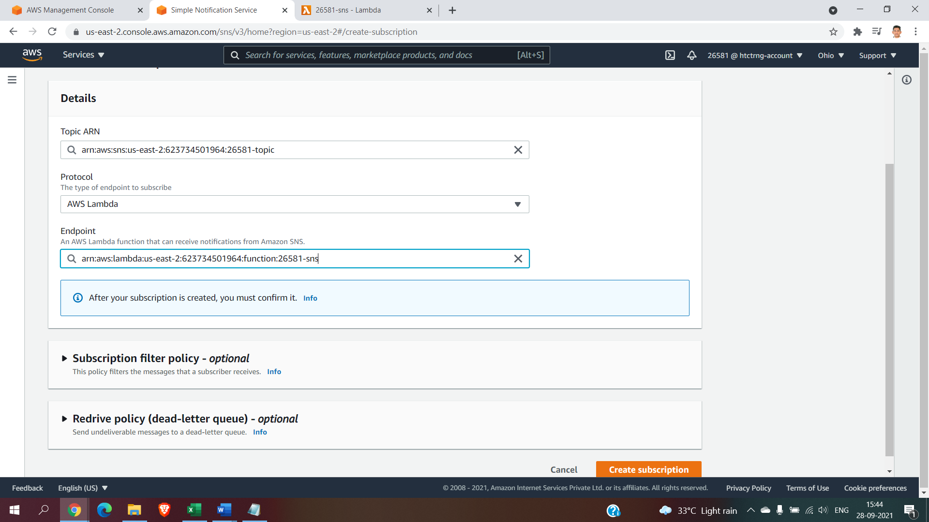

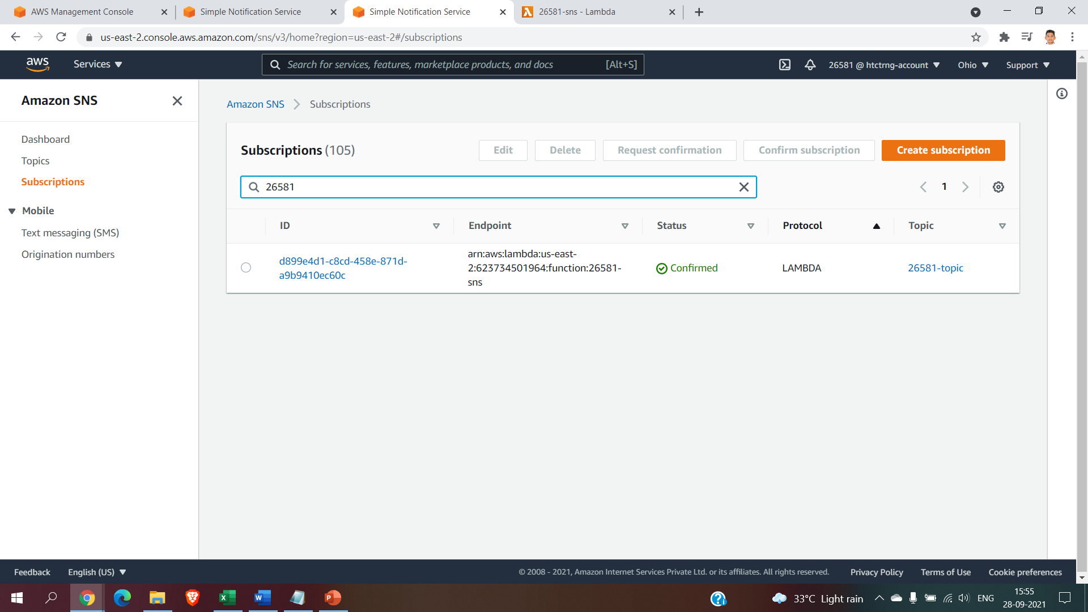

After subscription is created we have to go to the topic

Inside the topic we have to click the publish message

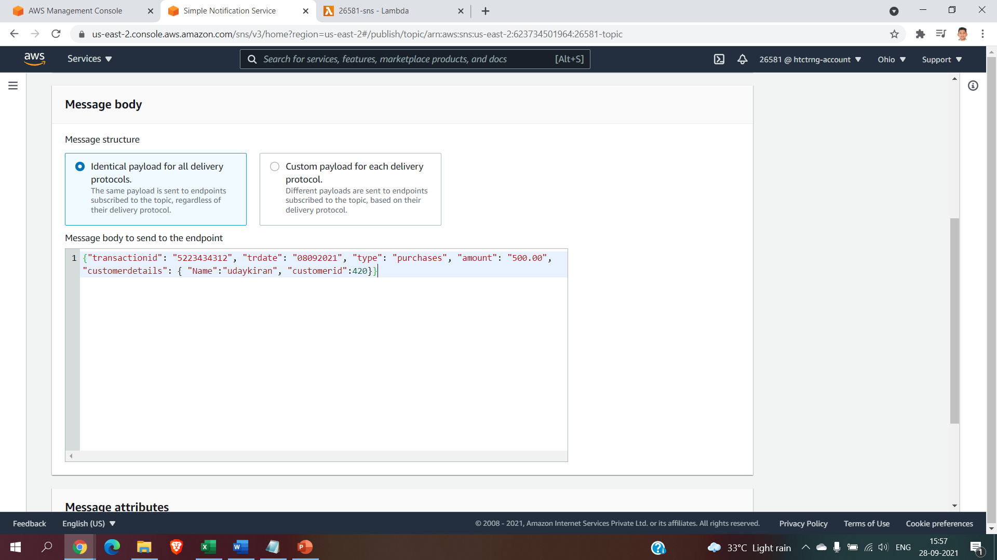

{"transactionid": "5223434312", "trdate": "08092021", "type": "purchases", "amount": "500.00", "customerdetails": { "Name":"udaykiran", "customerid":420}}

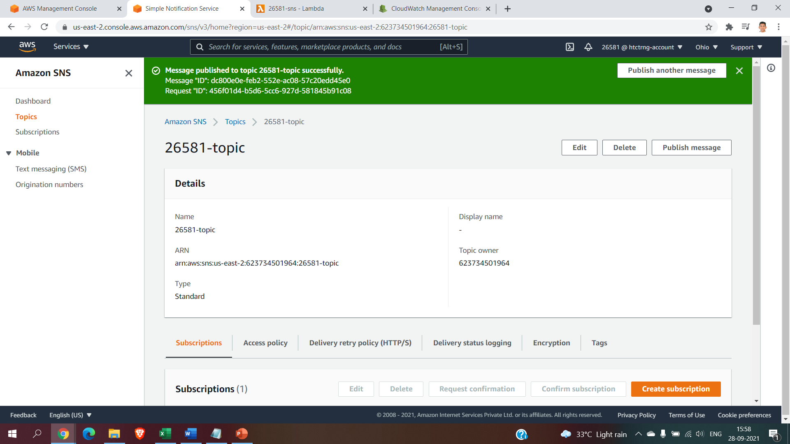

Seeing that in the cloudwatch:  
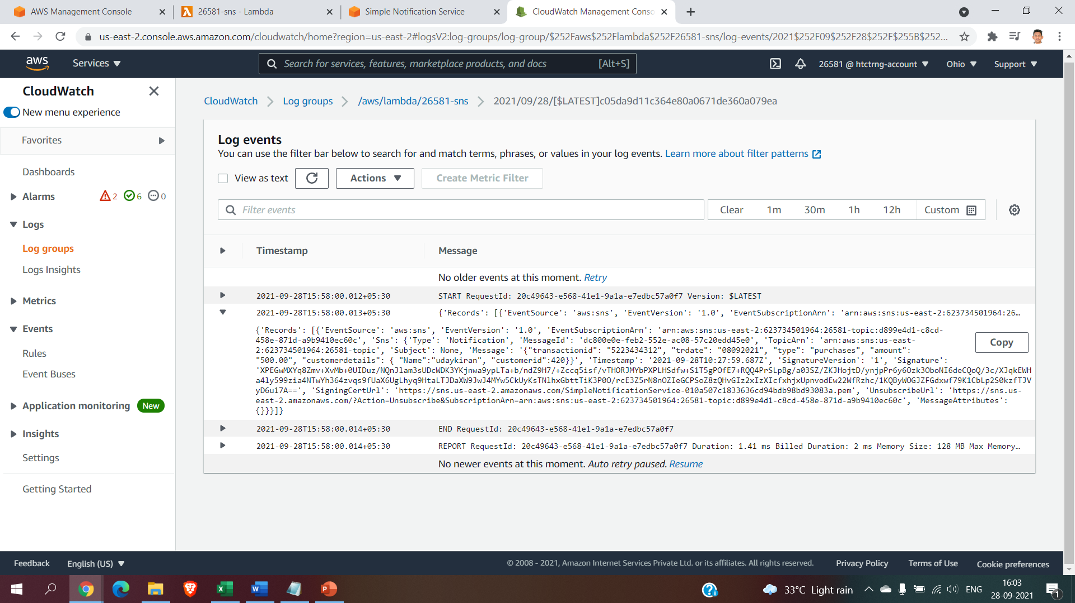

Creating a bucket:

Creating an s3 bucket

Create another lambda function to acess the transform inside the kinesis data firehose

After created the bucket create the kinesis data firehose

Give s3 full acess

After the stream is created publish the message in the sns

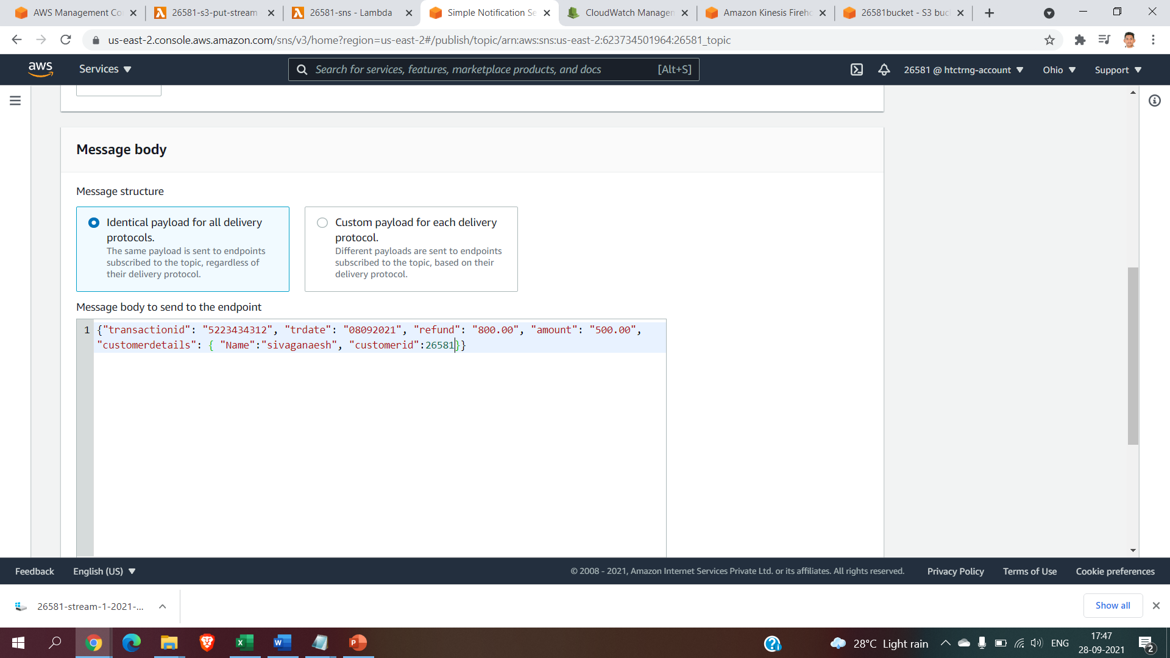

{"transactionid": "5223434312", "trdate": "08092021", "type": "purchases", "amount": ["1000.00", "9000.00", "60.00"], "customerdetails": { "Name":"sivaganaeesh", "customerid":26581}}

After the message is published check it in the cloud watch

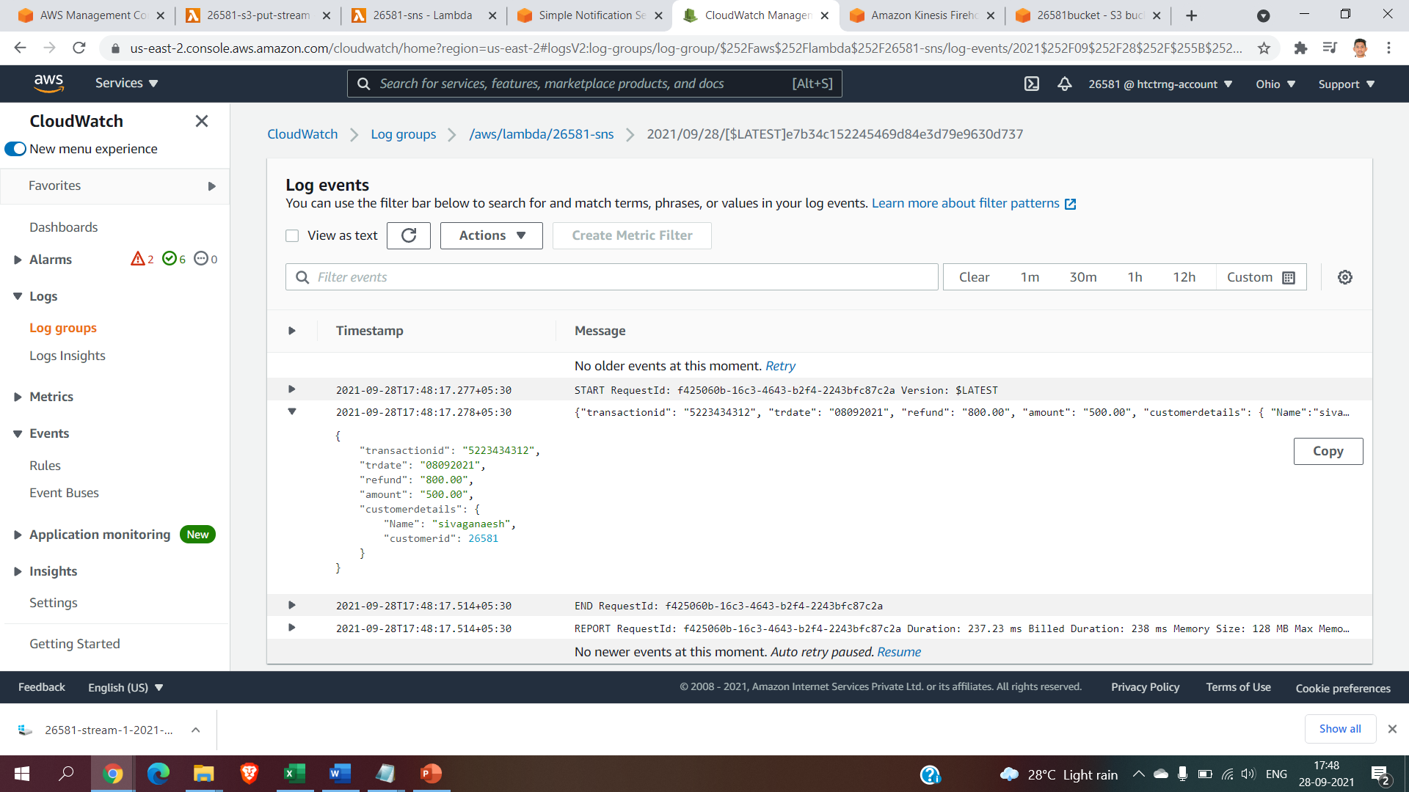

Check it in the destination i.e inside the s3 bucket:

